Date Display Cubes Curriculum

By Samuel Wang

# Learning Objectives:

The concept of “dates” is an abstract concept, different than one like the weather, which is sensory. It is a central characteristic of every day. This calendar attempts to bring a tactile representation of dates

## Months and Days (Lesson 1)

* 1. A date is comprised of the month, day, and day of the week
  2. There are 12 months in a year
  3. Each month has a certain number of days (28-31)
  4. There are seven days of the week

## Days of the week (Lesson 2)

* 1. There are seven days of the week
  2. Cultural norms - eg. the concept of the “weekend”

## Relationship between dates and the day of week (Lesson 3)

* 1. Depending on the year, Jan. 2nd is a different day of the week
  2. Different events on the same days of the week will fall on dates

## Why days of the week are important (Lesson 3)

* 1. Determines the of date of some holidays (see chart)
  2. Cultural norms - eg. the concept of the “weekend”

# Inventory

* 1 Day of the Week Cube
* 2 Number Cube
* 1 Month Cube

# Lesson 1: Months and Days

## Information for teacher to give:

3 different pieces of information in a calendar date: Month, Day of the Week, and Day

There are 12 months in a year (January, February, March, April, May, June, July, August, September, October, November, and December)

Each of these months is comprised of a certain number of days

January: 30 days

March: 31 days

February 28 days

To differentiate between the days in a month, each is assigned a number (eg. 1, 2, 3, etc.)

## Activity:

Students should be given the month and day cubes and play to see the options

## Follow up questions:

### How many months are there in a year? (Answer: 12)

### What is the 4th month of the year? (Answer: April)

### What is the 8th month of the year? (Answer: August)

### What is the 11th month of the year? (Answer: November)

### Which month were you born in?

# Lesson 2: Days of the Week

## Information for teacher to give:

Each day is a specific day of the week (Monday, Tuesday, Wednesday, Thursday, Friday, Saturday, and Sunday); There are seven days of the week.

Events can be scheduled by the day of the week. For example, [example from teacher]. (Example: I go to the BWSI spring program every Saturday)

Certain cultural customs exist with days of the week. For example, Saturday and Sunday are the “weekend”; while Monday, Tuesday, Wednesday, Thursday, and Friday are the weekday/business days

Give Students day of week cube and ask them to feel the various faces

## Follow up questions: (to be answered with the cube)

### Which day comes after Tuesday? (Answer: Wednesday)

### Which day comes after Friday? (Answer: Saturday)

### What day is it today?

### What day will it be tomorrow?

### What day will it be in three days?

### What day was it two days ago?

### What activities do you go to depending on the weekend?

# Lesson 3: How are dates and days of the week related?

## Information for teacher to give:

What’s your birthday?

365/366 days in a year (Not divisible by seven)

In 2021, this is in Day of Week, in 2020 this is this day of week

Arrange this date on using all 3 cubes

## Resource for teacher:

A calendar for 2020 and 2021. Alternatively, a procedure for calculating the day of the week for a date can be found below.

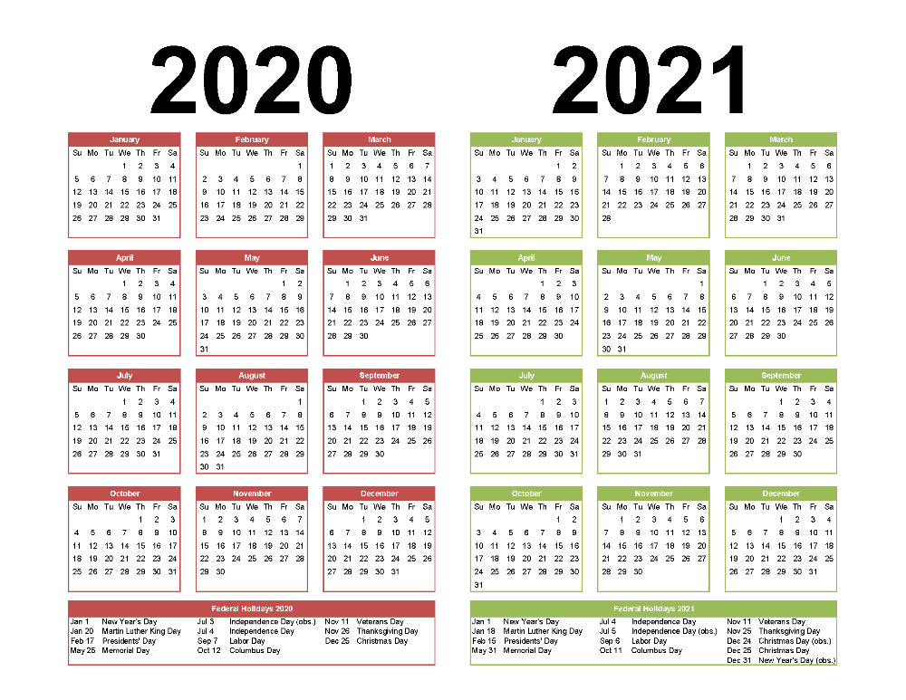

## Followup:

Federal Holidays (below), or Birthdays of classmates (to be constructed using date cubes)

|  |  |  |  |
| --- | --- | --- | --- |
|  | 2021 | 2020 | 2019 |
| New Year's Day (1/1) | Friday | Wednesday | Tuesday |
| Martin Luther King Jr. Day* | Monday (1/18) | Monday (1/20) | Monday (1/21) |
| President’s Day* | Monday (2/15) | Monday (2/17) | Monday (2/18) |
| Memorial Day* | Monday (5/31) | Monday (5/25) | Monday (5/27) |
| Independence Day (7/4) | Monday | Saturday | Thursday |
| Labor Day* | Monday (9/6) | Monday (9/7) | Monday (9/2) |
| Columbus Day* | Monday (10/11) | Monday (10/12) | Monday (10/14) |
| Veterans Day (11/11) | Thursday | Wednesday | Monday |
| Thanksgiving* | Thursday (11/25) | Thursday (11/26) | Thursday (11/28) |
| Christmas Day (12/25) | Sunday | Friday | Wednesday |
| New Year's Day (12/31) | Friday | Thursday | Tuesday |

*Holiday set by day of the week, rather than a specific day

## Calculating the day of the week of a date

(From [University of Waterloo](https://cs.uwaterloo.ca/~alopez-o/math-faq/node73.html))

* Take the last two digits of the year.
* Divide by 4, discarding any fraction.
* Add the day of the month.
* Add the month's key value: JFM AMJ JAS OND 144 025 036 146
* Subtract 1 for January or February of a leap year.
* For a Gregorian date, add 0 for 1900's, 6 for 2000's, 4 for 1700's, 2 for 1800's; for other years, add or subtract multiples of 400.
* For a Julian date, add 1 for 1700's, and 1 for every additional century you go back.
* Add the last two digits of the year.
* Divide by 7 and take the remainder.
* What written content is needed to ensure a student uses the object correctly and learns the lessons